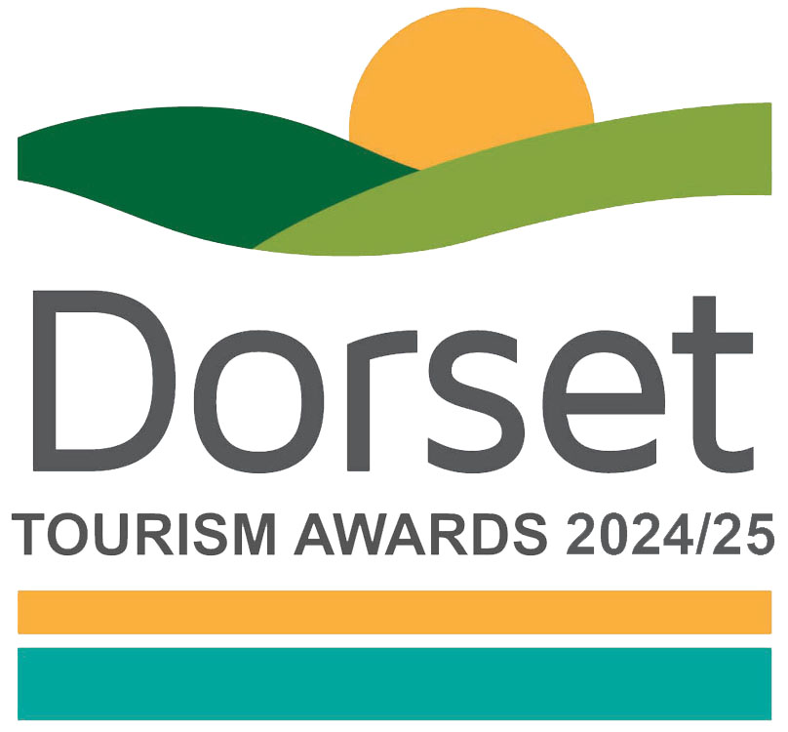

Tourism Event / Festival of the Year

Recognises providers of truly memorable and immersive tourism events and festivals

This sample application form is for information only and all applications must be made via the online application system.

Eligibility criteria

- Events and Festivals making a contribution to the visitor economy with a significant proportion of business generated by people visiting from outside the local area.
- Events could include festivals, fairs, carnivals, shows or celebrations. They can be paid entry or free but should demonstrate innovation and distinctiveness
- The event can be a one off or a rolling series of annual events.
- Events of all sizes can apply as this category is judged within the context and style of the business.
- Only tourism events who directly serve the end-users are eligible (ie the tourist/ visitor/ guest). Business to business agencies or intermediaries eg that manage business to consumer (B2C) presence for tourism events would not be eligible.
- Events that serve food must have a minimum food hygiene rating of three out of five. The competition organisers reserve the right to refuse an application if this minimum requirement is not met at any point prior to the awards ceremony. An exception is made for new businesses who have not yet been graded
- The event / festival must take place between 1st September 2023 and 31st August 2024.
- Applications from a chain or group operator must relate to a single event

Applicant & business details
(not scored)

Applicant’s name:

Enter the applicant’s name here.

Applicant’s job title:

Enter the applicant’s job title here.

Applicant’s phone number:

Enter the applicant’s phone number here.

Applicant’s email:

Enter applicant’s email here.

Event name:
Name used to promote the event as you wish it to appear in all publicity materials, on certificates, in presentations etc.:
Enter name here.

Event address:
Enter address here.

Event Date:
Enter the date including year of your event here (note eligibility criteria)

Promotional Description
Provide a promotional description of your event.
- Focus on its strengths and stand out features
- This wording will be used in PR and awards literature
- Wording provided is subject to edit
- 120 words maximum

Enter the promotional description here.

Promotional Images
Provide up to three landscape high resolution photos.
- Photos should be high quality and truly showcase your event
- Photos should not be edited in any way eg embedded text or logos, a collage
- Only include photos that you own the copyright for
- If the photo requires a credit eg photographer, please provide details
- These photos will be used in PR and awards literature

Background
(Not scored)

Briefly outline the story of your event (250 words maximum).
For example:
- Length of time event has been running
- Target market(s) and typical customer profile
- Key milestones in developing the event
- Indication of size of event
- Number of staff employed, if any

Enter information on the background of your event here.

List any awards, ratings and accolades received in the last two years. Include the title, awarding body, level and date (including year) achieved.
For example:
- Successes in this competition and the VisitEngland Awards for Excellence
- TripAdvisor Accolades
- Green Tourism award
- VisitEngland quality assessment, local quality accreditation
- Specific event / festival accolades
- Local business award eg FSB, Chamber of Commerce

Enter information on any awards, ratings or accolades here.

There is no requirement for your business to be quality assessed. However, if you have an independent quality assessment/mystery shopping report from the last two years, you might wish to upload it here (optional).

Enter information on any quality assessments here.

Online presence & reviews
(This section is 30% of the final score)
- Social Media & Website = 20%
- Online Reviews = 10%

Provide links to your online presence relating to this category, which will be reviewed and scored by judges in addition to your answers to the four questions. Other sites may also be checked. As part of this review, judges will be looking for evidence of your commitment to Accessible and Inclusive Tourism and Ethical, Responsible and Sustainable Tourism in addition to your event.

Enter the website URL here.

Accessibility & inclusivity information
Provide links to your accessibility and inclusivity information.

Enter the accessibility & inclusivity information URL here.

Sustainability information
Provide links to your sustainability information.

Enter the sustainability information URL here.

Provide links to all business pages/profiles on Facebook, Instagram etc. and X (formerly Twitter) handles

Enter the social media URL here.

Online review sites
Provide specific links to customer review listings for your business eg TripAdvisor, Facebook, Google etc

Enter the online review URLs here.

Question 1 - Your Top Qualities
(This question is 20% of the final score)

Tell us about up to five ways in which your event is impressive compared to other events (500 words maximum).

Describe the unique selling points, strengths and essence of your event. Judges will be looking for detailed examples of quality from across the event. One or more of the following example areas may be relevant to address in your answer (it is not mandatory to cover every area) and you may have others:
- Quality of your core product and customer experience
- Added extras that delight your visitors, how you exceed expectations before, during and after your event
- How you care for your team and training with specialist skills specific to the changing needs of visitors
- Use and promotion of local services and suppliers, including food & drink offer centred on locally sourced produce
- Innovative marketing and PR, including partnerships with other businesses
- Innovative adaption, diversification and/ or resilience building
- Facilities and welcome for people with a range of accessibility requirements eg this may include information provision, adapted customer experiences, accessible facilities for people with a range of impairments, employing disabled staff and staff disability awareness training
- Managing and improving environmental, social and economic impacts eg this may include a carbon reduction plan, energy and waste monitoring, green transport, community and charitable initiatives and responsible purchasing

Enter answer to question 1 here.

Links to relevant supporting evidence online (optional):
It is not a requirement to submit supporting evidence; however, if you do, ensure that the focus is on the quality and relevancy of the evidence submitted to this question rather than quantity.
Any written answers that are included within the supplementary evidence, attempting to circumvent the question word counts, will be disregarded.

Enter links to supplementary evidence here.

Question 2 - Your Recent Improvements
(This question is 20% of the final score)

Tell us about up to five ways in which you have developed your event and/or improved the visitor experience over the last two years (500 words maximum).

Explain your reasons for making the improvements and indicate which parts of the event are impacted. Judges will be looking for examples of improvements from across the event. One or more of the following example areas may be relevant to address in your answer (it is not mandatory to cover every area) and you may have others too:
(Only include examples of improvements undertaken in the last two years.)
- Have your improvements been based on customer feedback or staff suggestions
- Promotional initiatives eg new website
- Improving the skills of you and your team
- Development and changes made to your event eg upgrade of facilities, enhancements to your services, innovation etc
- Facilities and welcome for people with a range of accessibility requirements eg this may include information provision, adapted customer experiences, accessible facilities for people with a range of impairments, employing disabled staff and staff disability awareness training
- Managing and improving environmental, social and economic impacts eg this may include a carbon reduction plan, energy and waste monitoring, green transport, community and charitable initiatives and responsible purchasing
- Innovative adaption, diversification and/ or resilience building
- Use of digital technologies such as automated services, robotics and artificial intelligence (AI)
- If your entry relates to a one off event, please focus on the development element of your event, eg areas you have taken into consideration when planning
- Approximate date of improvement

Enter answer to question 2 here.

Links to relevant supporting evidence online (optional):
It is not a requirement to submit supporting evidence; however, if you do, ensure that the focus is on the quality and relevancy of the evidence submitted to this question rather than quantity.
Any written answers that are included within the supplementary evidence, attempting to circumvent the question word counts, will be disregarded.

Enter links to supplementary evidence here.

Question 3 - Your Results
(This question is 15% of the final score)

Tell us about three evidenced or anticipated successes from your event providing figures where relevant (these may relate to online activities) (300 words maximum).

Judges will be looking for detailed examples of successes from across the event. One or more of the following example areas may be relevant to address in your answer (it is not mandatory to cover every area) and you may have others too:
- Whether you are able to attribute success directly to any of the improvements that you’ve made (mentioned in Question 2)
- Overall growth of event
- Percentage increase in visitor numbers, sales, customer satisfaction, online booking
- Wastage reduction and improvement in environmental impact, savings made
- Increase in repeat business (unless a one off event)
- Business generated from marketing activity
- Growth of social media following and engagement
- The significance of the level of impact on your event

Enter answer to question 3 here.

Links to relevant supporting evidence online (optional):
It is not a requirement to submit supporting evidence; however, if you do, ensure that the focus is on the quality and relevancy of the evidence submitted to this question rather than quantity.
Any written answers that are included within the supplementary evidence, attempting to circumvent the question word counts, will be disregarded.

Enter links to supplementary evidence here.

Question 4 – Your Future Plans
(This question is 15% of the final score)

- Tell us about three ways you will develop and promote your event over the next year and the reasons why (300 words maximum).

If your entry relates to a one off event that won’t run again, please include details of next steps, eg actions with feedback, PR etc.

Judges will be looking for detailed examples of future plans from across the event with a clear rationale. One or more of the following example areas may be relevant to address in your answer (it is not mandatory to cover every area) and you may have others too:
- Continued adaptation, diversification and resilience building
- Facilities and welcome for people with a range of accessibility requirements eg this may include information provision, adapted customer experiences, accessible facilities for people with a range of impairments, emploing disabled staff and staff disability awareness training
- Managing and improving environmental, social and economic impacts eg this may include a carbon reduction plan, energy and waste monitoring, green transport, community and charitable initiatives and responsible purchasing
- Development, innovation, information provision, upgrade of facilities, enhancements to your event
- Improving the skills of you and your team
- Marketing and PR, including partnerships with other businesses
- Operational efficiency
- Use of digital technologies such as automated services, robotics and artificial intelligence (AI)

Enter answer to question 4 here.

Links to relevant supporting evidence online (optional):
It is not a requirement to submit supporting evidence; however, if you do, ensure that the focus is on the quality and relevancy of the evidence submitted to this question rather than quantity.
Any written answers that are included within the supplementary evidence, attempting to circumvent the question word counts, will be disregarded.

Enter links to supplementary evidence here.

