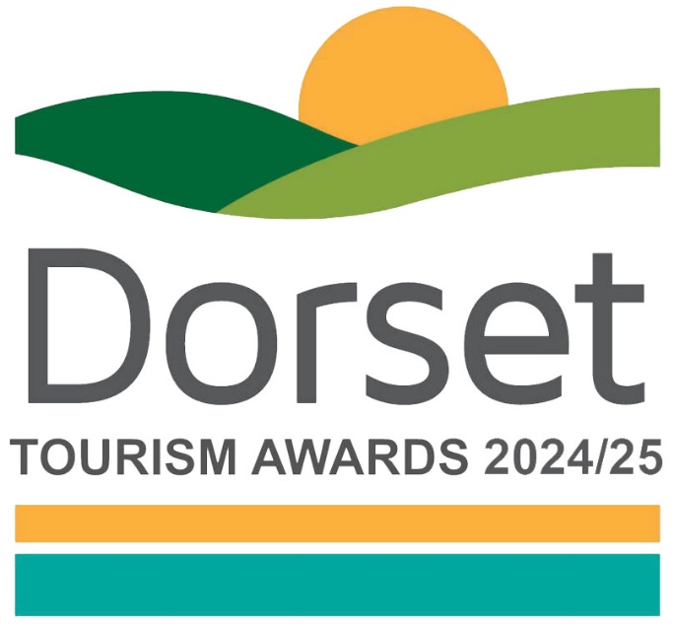

Business Events Venue of the Year

Recognises business events venues that demonstrate an excellent understanding of the market, exceeding the expectations of their clients and have a strategic plan for future development within this area, with clear goals.

This sample application form is for information only and all applications must be made via the online application system.

Eligibility criteria

- Directly involved in tourism, making a contribution to the visitor economy with a significant proportion of business generated by people visiting from outside the local area.
- Any venue that hosts business events (meetings, incentives, conferences, exhibitions) and actively works to increase business events business e.g. hotels, conference centres, exhibition venues, leisure venues.
- Clients may be exclusively from UK markets or also be from international markets.
- Businesses that serve food must have a minimum food hygiene rating of three out of five. The competition organisers reserve the right to refuse an application if this minimum requirement is not met at any point prior to the awards ceremony. An exception is made for new businesses who have not yet been graded.
- Businesses of all sizes can apply as this category is judged within the context and style of the business.
- Businesses that have been trading for at least three months and up to two years when applications open, are strongly recommended to apply to the New Tourism Business of the Year category before considering applying to any other categories
  - For the purpose of eligibility for this competition, ‘trading’ means serving customers. If the business has not been trading this long, then they will need to wait to apply to the competition in 2025/26
- Applications from a chain or group operator must relate to a single site and not multiple sites.

Applicant & business details
(not scored)

Applicant’s name:

Enter the applicant’s name here.

Applicant’s job title:

Enter the applicant’s job title here.

Applicant’s phone number:

Enter the applicant’s phone number here.

Applicant’s email:

Enter applicant’s email here.

Business name:
Name of business application relates to. Give the name used to promote the business, as you wish it to appear in all publicity materials, on certificates, in presentations etc.:

Enter your business name here.

Business address:

Enter your business address here.

Closures during judging period (the judging period runs from 1st June 2024– 28th February 2025):
Enter closures during the judging period here.

Age of business

When did the business relating to this application start trading?
Note: For the purposes of eligibility 'trading' means serving customers.

Promotional Description
Provide a promotional description of your business.
- Focus on its strengths and stand out features
- Write your description with regard to this category
- This wording will be used in PR and awards literature
- Wording provided is subject to edit
- 120 words maximum

Enter the promotional description here.

Promotional Images
Provide up to three high resolution photos.
- Photos should relate to this category
- Photos should not be edited in any way e.g. embedded text or logos, a collage
- Only include photos that you own the copyright for
- If the photo requires a credit e.g. photographer, please provide details
- These photos will be used in PR and awards literature

Background
(not scored)

Briefly outline the story of your business (250 words maximum).
For example:
- Length of time business has been trading and time under current ownership
- Target market(s) and typical customer profile
- Key milestones in developing the business
- Indication of size of business
- Number of staff employed, if any

Enter information on the background of your business here.

List any awards, ratings and accolades received in the last two years. Include the title, awarding body, level and date achieved.
For example:
- Successes in this competition and the VisitEngland Awards for Excellence
- AEO Excellence Awards (for AEV members)
- Conference and Incentive Travel (C&IT) Awards
- M&IT Awards
- miaList (Meetings Industry Association Awards)
- AIM Secure (Meetings Industry Association Accreditation)

Enter information on any awards, ratings or accolades here.

There is no requirement for your business to be quality assessed. However, if you have an independent quality assessment/mystery shopping report from the last two years, you might wish to upload it here (optional).

Enter information on any quality assessments here.

Online presence & reviews
(this section is 30% of the final score)
- Social Media & Website = 20%
- Online Reviews = 10%

Provide links to your online presence, which will be reviewed and scored by judges in addition to your answers to the four questions. Other sites may also be checked.
As part of this review, judges will be looking for evidence of your commitment to Accessible and Inclusive Tourism and Ethical, Responsible and Sustainable Tourism.

Enter the website URL here.

Accessibility & inclusivity information
Provide links to your accessibility and inclusivity information.

Enter the accessibility & inclusivity information URL here.

Sustainability information
Provide links to your sustainability information.

Enter the sustainability information URL here.

Provide links to all business pages/profiles on Facebook, Instagram etc. and X (formerly Twitter) handles

Enter the social media URL here.

Online review sites
Provide specific links to customer review listings for your business e.g. TripAdvisor, Facebook, Booking.com, Google, Euan’s Guide, UpFront Reviews

Enter the online review URL here.

Question 1 - Your Top Qualities
(this question is 20% of the final score)

Tell us about up to five ways in which your business is impressive in meeting the needs of business events clients and delegates compared to your competitors (500 words maximum).

Describe the unique selling points, strengths and essence of your business.
Judges will be looking for detailed examples of quality from across the business.
One or more of the following example areas may be relevant to address in your answer (it is not mandatory to cover every area):
- Quality of your core product and customer experience
- Approach to supporting clients to ensure success in their events (e.g. maximise their Return on Objectives (ROO)
- Use and promotion of local suppliers, including food & drink offer centred on locally sourced produce
- Innovative marketing and PR, including partnerships with other businesses
- Services to help clients plan and deliver their events e.g. providing a meeting design expert
- Flexibility of venue to create usable space
- Facilities and welcome for people with a range of accessibility requirements
  - For example, this may include information provision, adapted customer experiences, accessible facilities for people with a range of impairments, employing disabled staff and staff disability awareness training
- Managing and improving environmental, social and economic impacts
  - For example, this may include a carbon reduction plan, energy and waste monitoring, green transport, community initiatives and responsible purchasing
- Innovative adaption, diversification and/ or resilience building
  - For example, this may include how the venue has adapted to host hybrid events

Enter answer to question 1 here.

Links to relevant supporting evidence online (optional):
It is not a requirement to submit supporting evidence; however, if you do, ensure that the focus is on the quality and relevancy of the evidence submitted rather than quantity.
Any written answers that are included within the supplementary evidence, attempting to circumvent the question word counts, will be disregarded.

Enter links to supplementary evidence here.

Question 2 - Your Recent Improvements
(this question is 20% of the final score)

Tell us about up to five ways in which you have developed your business and/or improved the experience for business events clients and delegates over the last two years (500 words maximum).

Explain your reasons for making the improvements and indicate which parts of the business are impacted. Judges will be looking for examples of improvements from across the business. One or more of the following example areas may be relevant to address in your answer (it is not mandatory to cover every area):
(Only include examples of improvements undertaken in the last two years.)
- Promotional initiatives e.g. new website
- Improving the skills of you and your team
- Expansion, upgrade of facilities, enhancements to your services
- Facilities and welcome for people with a range of accessibility requirements
  - For example, this may include information provision, adapted customer experiences, accessible facilities for people with a range of impairments, employing disabled staff and staff disability awareness training
- Managing and improving environmental, social and economic impacts
  - For example, this may include a carbon reduction plan, energy and waste monitoring, green transport, community initiatives and responsible purchasing
- Innovative adaption, diversification and/ or resilience building
  - For example, this may include how the venue has adapted to host hybrid events
- Use of digital technologies, such as automated services, robotics and artificial intelligence (AI)
- Reasons for making the improvements e.g. driven by customer feedback
- Approximate date of improvement

Enter answer to question 2 here.

Links to relevant supporting evidence online (optional):
It is not a requirement to submit supporting evidence; however, if you do, ensure that the focus is on the quality and relevancy of the evidence submitted rather than quantity.
Any written answers that are included within the supplementary evidence, attempting to circumvent the question word counts, will be disregarded.

Enter links to supplementary evidence here.

Question 3 - Your Results
(this question is 15% of the final score)

Tell us about three successes from the last year, in meeting the needs of business event clients and delegates, providing figures where relevant (300 words maximum).

Judges will be looking for detailed examples of successes from across the business.
One or more of the following example areas may be relevant to address in your answer (it is not mandatory to cover every area):
- Whether you able to attribute success directly to any of the improvements that you’ve made (mentioned in Question 2)
- Percentage increase in conversion of enquiries, sales, customer satisfaction and wastage reduction
- Increase in repeat business
- Business generated from marketing activity
- Growth of social media following and engagement
- The significance of the level of impact on your business

Enter answer to question 3 here.

Links to relevant supporting evidence online (optional):
It is not a requirement to submit supporting evidence; however, if you do, ensure that the focus is on the quality and relevancy of the evidence submitted rather than quantity.
Any written answers that are included within the supplementary evidence, attempting to circumvent the question word counts, will be disregarded.

Enter links to supplementary evidence here.

Question 4 – Your Future Plans
(this question is 15% of the final score)

Tell us about three ways you will develop and promote your business to meet the needs of business events clients and delegates over the next year and the reasons why (300 words maximum).

Judges will be looking for detailed examples of future plans from across the business, with a clear rationale. One or more of the following example areas may be relevant to address in your answer (it is not mandatory to cover every area):
- Continued adaption, diversification and resilience building
  - For example, this may include how the venue will adapt and introduce technical enhancements
- Facilities and welcome for people with a range of accessibility requirements
  - For example, this may include information provision, adapted customer experiences, accessible facilities for people with a range of impairments, employing disabled staff and staff disability awareness training
- Managing and improving environmental, social and economic impacts
  - For example, this may include a carbon reduction plan, energy and waste monitoring, green transport, community initiatives and responsible purchasing
- Expansion, upgrade of facilities, enhancements to your services
- Improving the skills of you and your team
- Marketing and PR, including partnerships with other businesses
- Operational efficiency
- Use of digital technologies, such as automated services, robotics and artificial intelligence (AI)

Enter answer to question 4 here.

Links to relevant supporting evidence online (optional):
It is not a requirement to submit supporting evidence; however, if you do, ensure that the focus is on the quality and relevancy of the evidence submitted rather than quantity.
Any written answers that are included within the supplementary evidence, attempting to circumvent the question word counts, will be disregarded.

Enter links to supplementary evidence here.

